4.Java Memory model?
-Describes how threads in the Java programming language interact through memory.
- specifies how the JVM works with the computer's memory (RAM).
-how java threads access the memory and how memory is organised in JVM
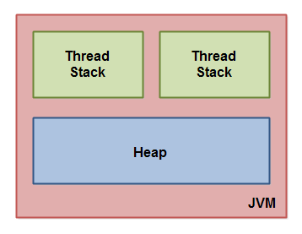
1.Each thread running in the Java virtual machine has its own thread stack.
2. The thread stack contains information about what methods the thread has . called to reach the current point of execution.
--The thread stack also contains all local variables for each method being executed (all methods on the call stack).
--A thread can only access it's own thread stack.
3.Local variables created by a thread are invisible to all other threads than the thread who created it
--All local variables of primitive types ( boolean, byte, short, char, int, long, float, double) are fully stored on the thread stack and are thus not visible to other threads.
--One thread may pass a copy of a pritimive variable to another thread, but it cannot share the primitive local variable itself.
4.The heap contains all objects created in your Java application, regardless of what thread created the object. This includes the object versions of the primitive types (e.g. Byte, Integer, Long etc.).
--- It does not matter if an object was created and assigned to a local variable, or created as a member variable of another object, the object is still stored on the heap.
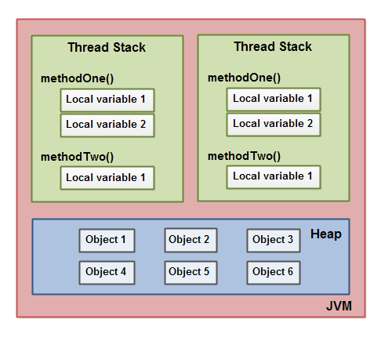
5.A local variable may also be a reference to an object. In that case the reference (the local variable) is stored on the thread stack, but the object itself if stored on the heap.
6.An object may contain methods and these methods may contain local variables. These local variables are also stored on the thread stack, even if the object the method belongs to is stored on the heap.

